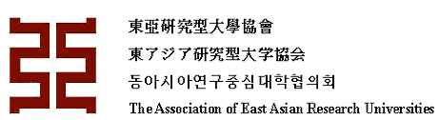

AEARU Global Learning Initiatives Program
Student Endorsement Form

Please fill out the form and submit the completed copy with your online application to the Global Learning Initiatives Program.

Student Information (to be complete by student)
Name of Student | Dachui Wang
Home University | University of Science and Technology of China
Student ID Number | PB2021888888
Department | School of Physical Sciences
Current Year of Study | Bachelor-Second Year
I would like to participate in the program in Fall 2023.

Endorsement (to be complete by university coordinator)
By signing and endorsing this form, you understand and agree the following: Please confirm the following statements to be true and sign and endorse in the space below.
- The student’s information listed above is accurate.
- The student is currently enrolled at your university and is not expected to graduate before the start of the Fall 2023 program.
- The student is approved to participate in the Fall 2023 program.
- The student’s participation may be counted towards the Global Learning Initiatives Program quota and will not in any way affect other programs, including balance of student exchange programs.

Name of University Coordinator | Jieqin Wang
Title of University Coordinator | Program Coordinator  Student Exchange  Office of International Cooperation
Email Address | outgoing@ustc.edu.cn
University Coordinator’s  Signature and Endorsement  Please provide official stamp/seal where relevant. | Please send the fill-in form to outgoing@ustc.edu.cn  The deadline for stamping is on July 29th at 6pm (GMT+8)  Date: DD/MM/YY

